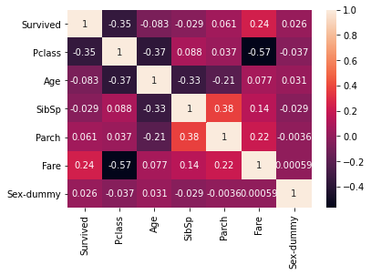

By analyzing this graph, I can observe that none of the input features have a collinearity with the “Survived” output feature which means there is no relation between them and if there is low. I can also see that half of the features are leaning more to negative collinearity while the other go towards positive collinearity. This means that most of these features are not going to be useful which could cause some trouble.

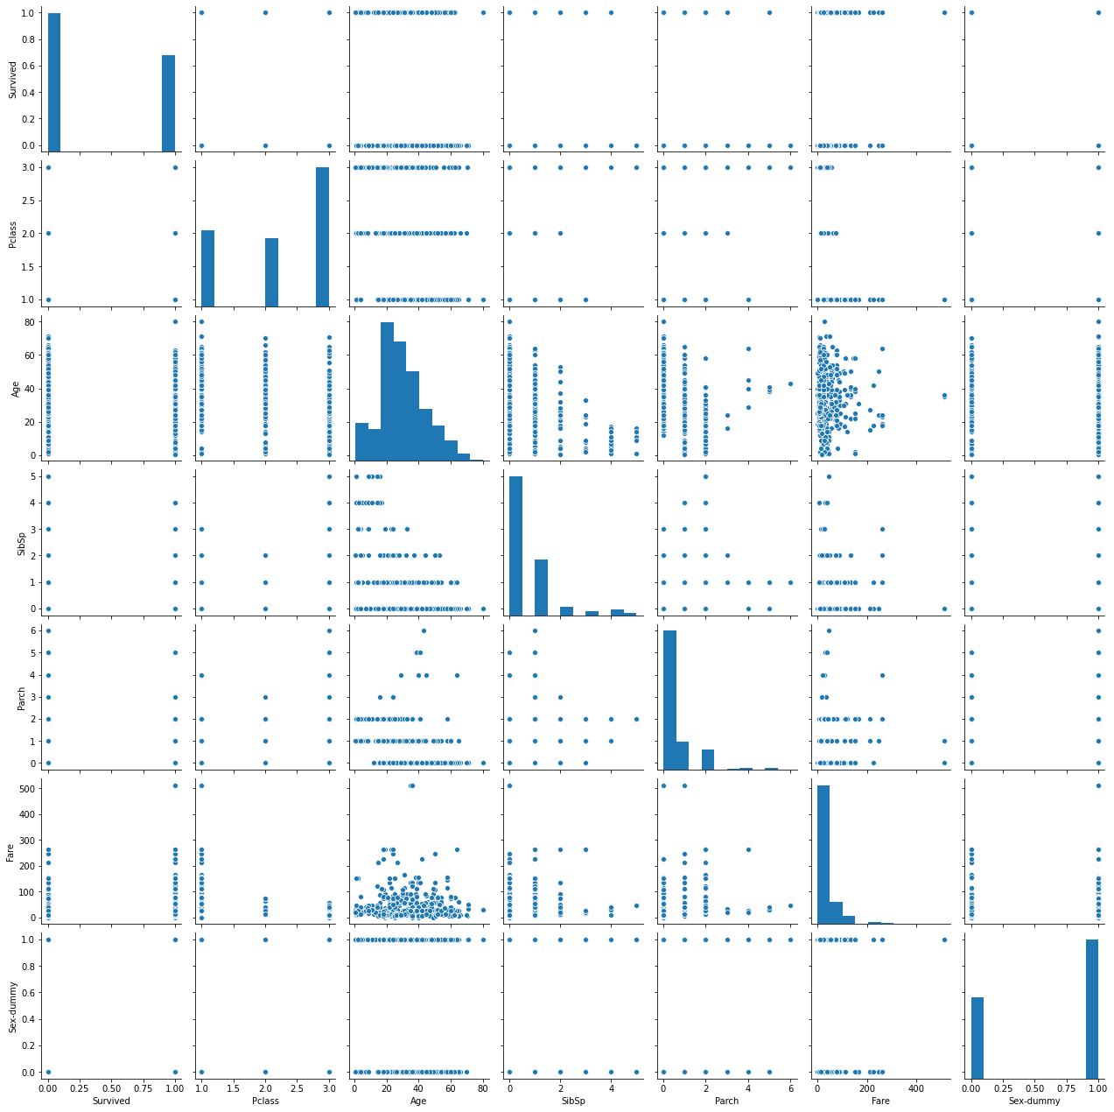

Watching the distribution of the Sex-dummy feature I can observer that most of the population is male. I can assume that this distribution is because men working in the ship are also included. W can also see a gaussian distributing on the age which makes the ages diverse. Also we see that we most definitely have a distribution problem with SibSp, Parch and Fare which could cause problems for the model.

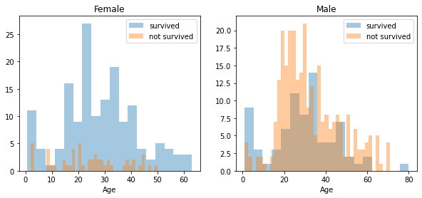

With this graph I found interesting that most of the survivors are females and they are gaussian distributed which males are evenly separated between dead or alive except for the ages between 0-15 which are kids and 80 which can mean that those ages were prioritize when it come to saves them.  
  
Finally with the models I found that a Decision Tree and a Random Forest were the best fits for this model but I could not get a score greater that 69 unless I increase the number of estimators which could be fix by adding more samples.